**Assignment 3 – Linux Practical Work**

**Course:** Operating Systems  
**Student:** Bek Madias  
**Date: 9/28/2025**

**1. Purpose of the Work**

The purpose of this practical assignment is to:

* Interact with the Linux terminal
* Practice archiving and compression, text commands, and navigation
* Install and update packages
* Create and edit files using **nano** and **vim**
* Create and run a small Python program
* Practice searching, counting, and redirecting outputs
* Gain confidence in using the Linux command line step by step

## ****2. Preparation****

As part of the preparation, I worked inside the **NDG Linux Essentials course** and completed **Chapter 9 and Chapter 10** with their corresponding labs and exams. Here’s what I practiced and learned:

### **Lab 9 – Archiving and Compression**

In this lab, I explored how to:

* Use the tar command to create and extract archives.
  + Example:
  + tar -cvf archive.tar file1 file2
  + tar -xvf archive.tar
* Apply different compression methods like **gzip** and **bzip2**.
  + Example:
  + gzip file1.txt
  + gunzip file1.txt.gz
* Combine archiving and compression in one step.
  + Example:
  + tar -czvf archive.tar.gz myfolder/
  + tar -xzvf archive.tar.gz
* Check archive contents without extracting (tar -tvf).

### **Lab 10 – Working with Text**

In this lab, I practiced working with text files using different commands:

* Viewing file contents with cat, more, and less.
* Searching for words inside files using grep.
  + Example:
  + grep "Linux" myfile.txt
* Sorting text with sort and removing duplicates with uniq.
* Redirecting outputs (>, >>) and using pipes (|) to combine commands.

### **Exams and Quizzes**

* Completed **Exam 9, Midterm Exam, and Exam 10** successfully.
* Screenshots of my **grades, attempt numbers** are attached as proof.

Link to: Practical Linux Tasks 21 page

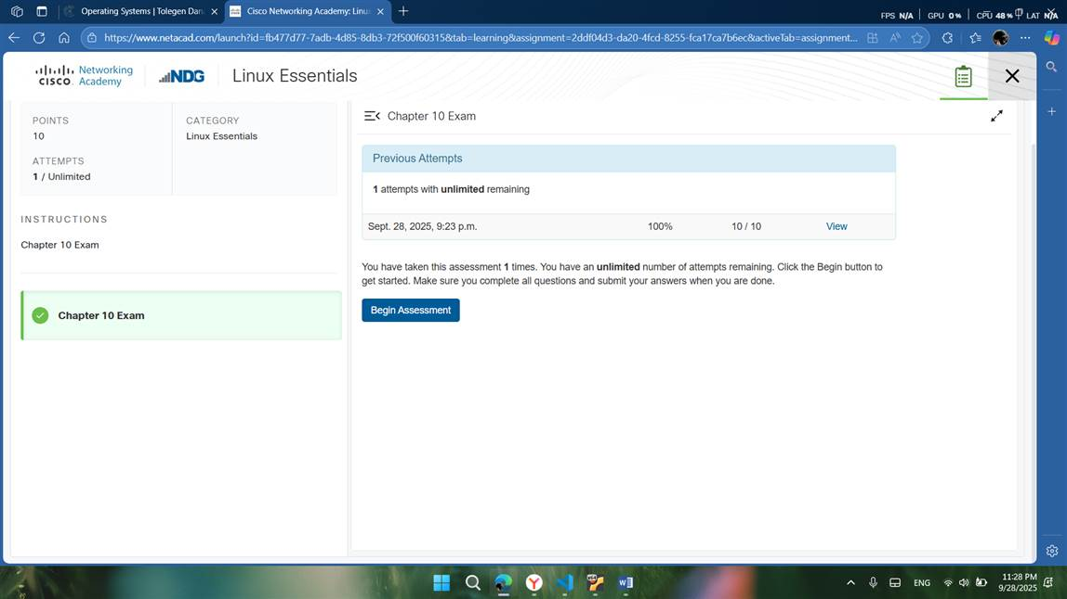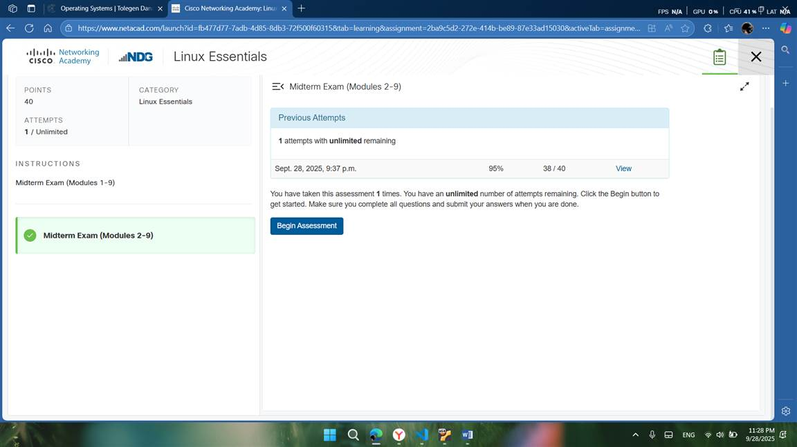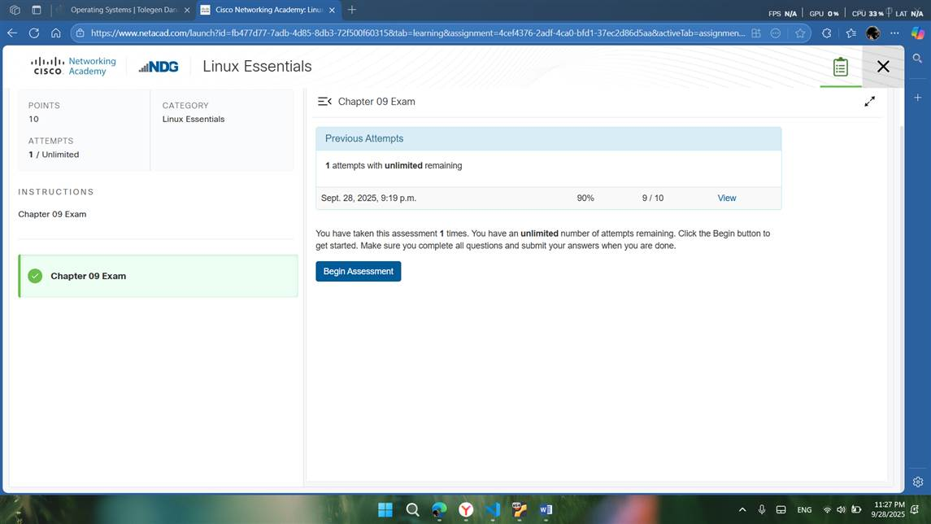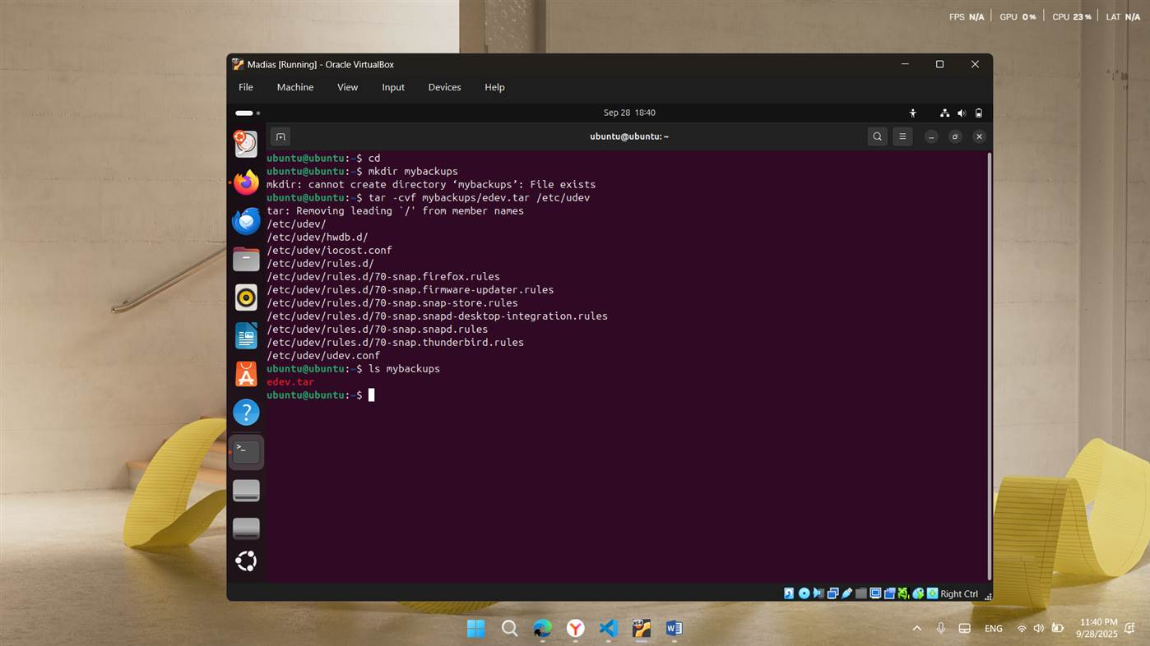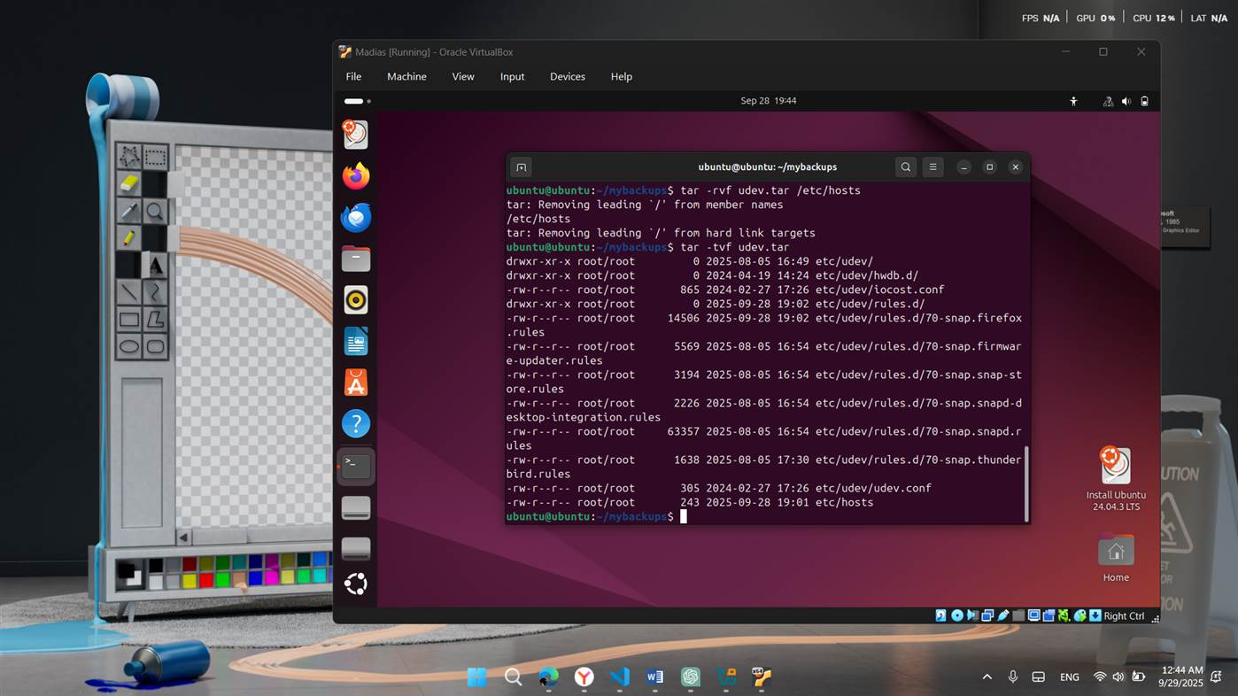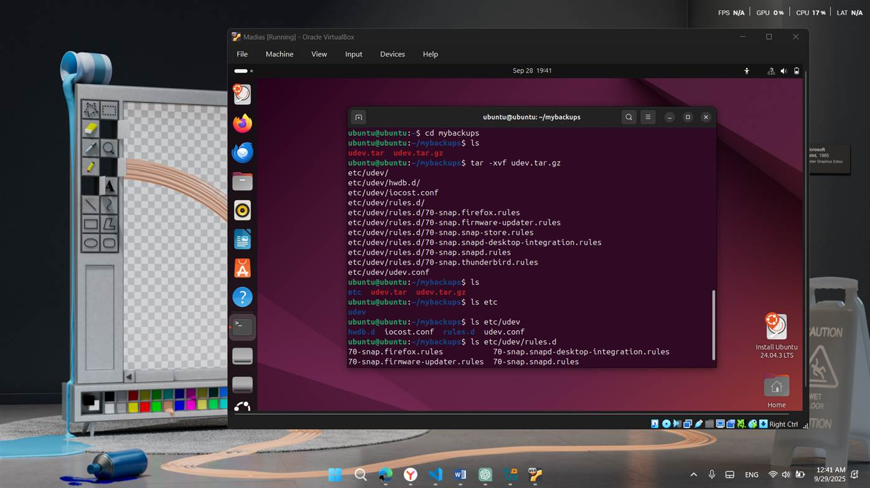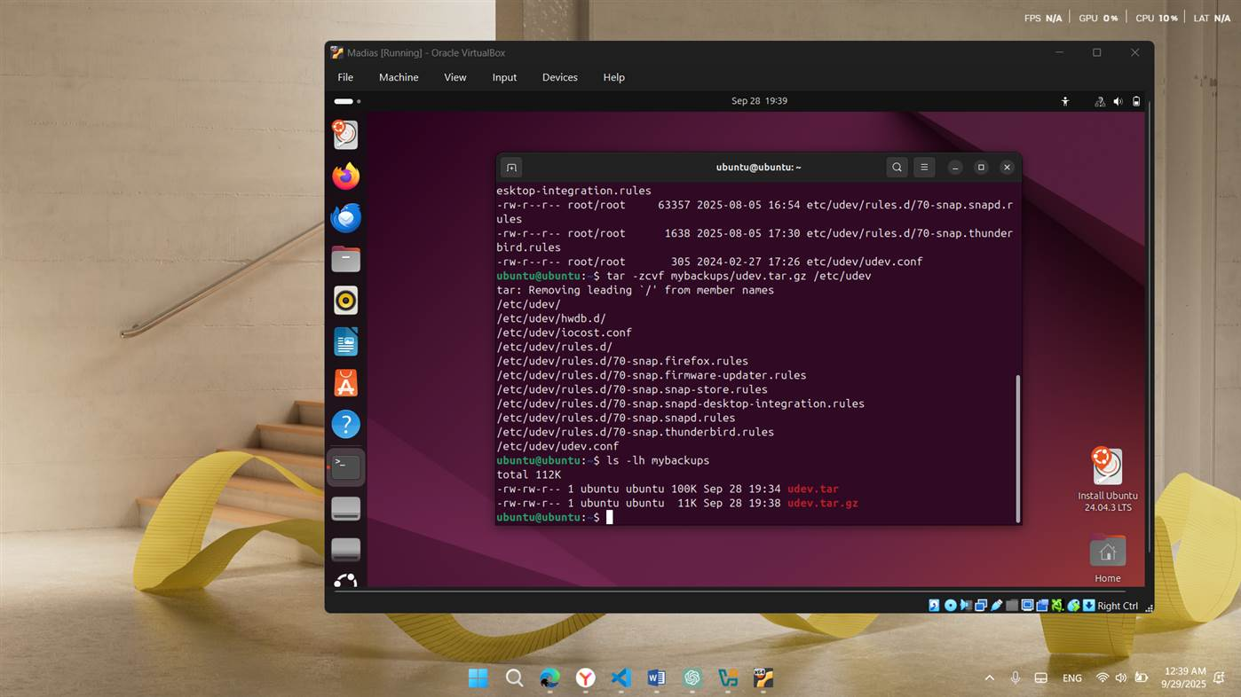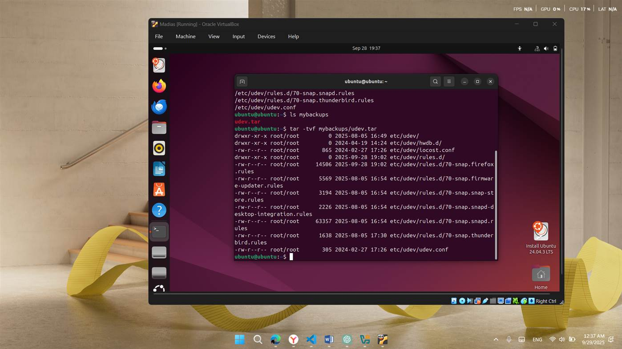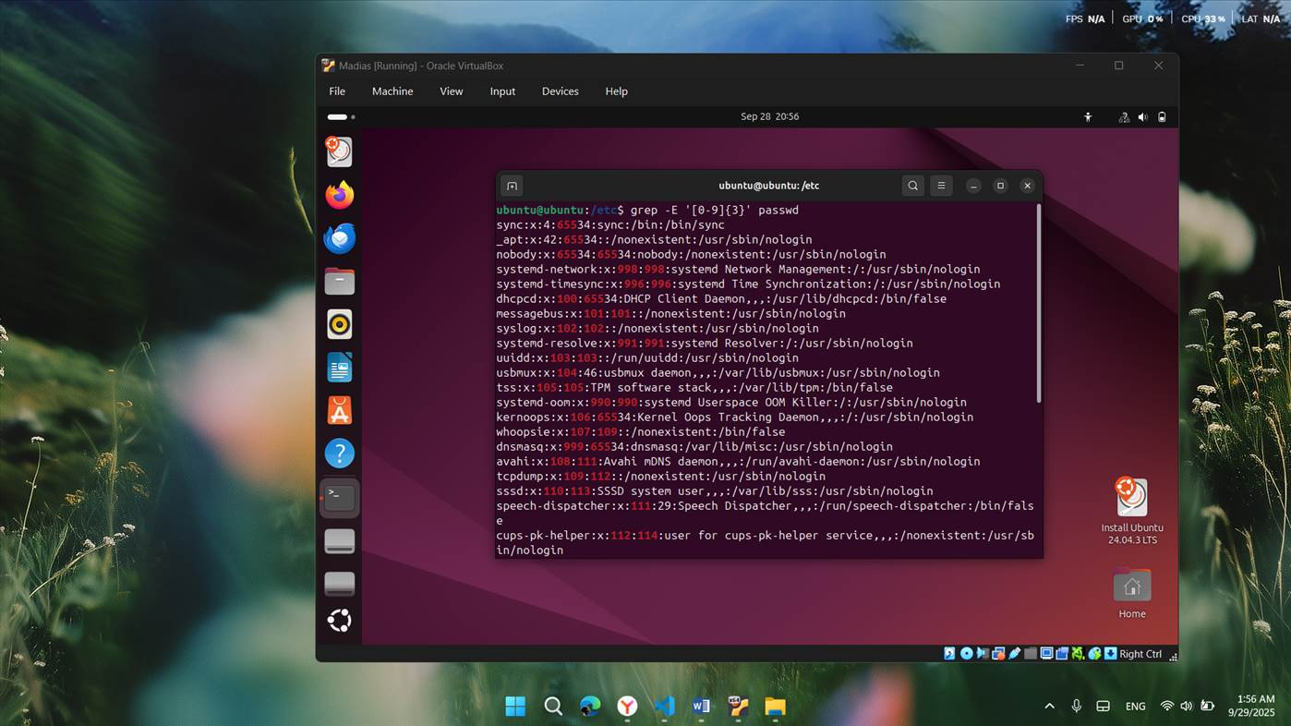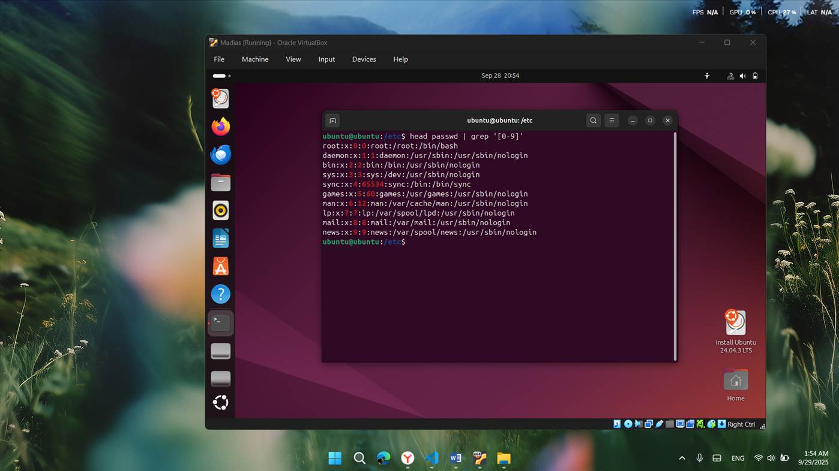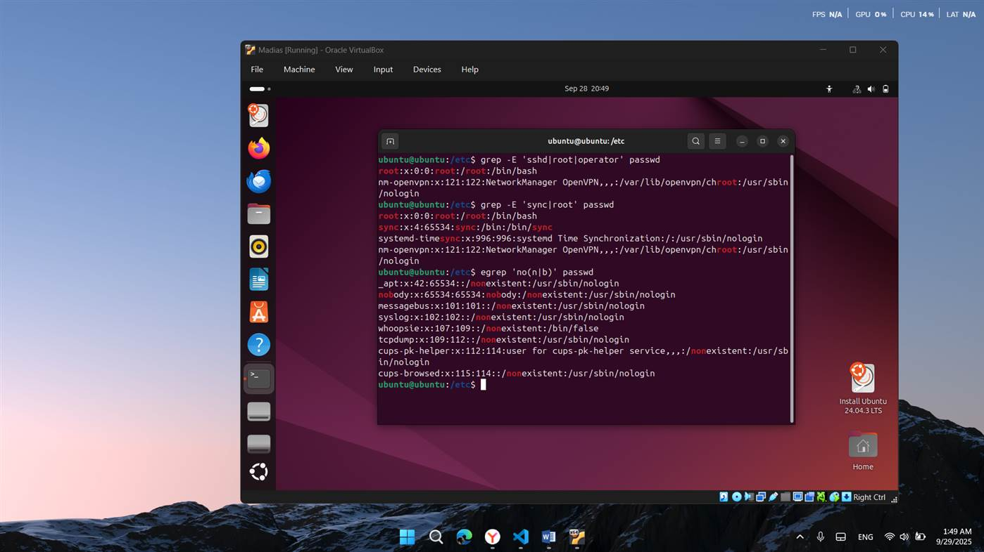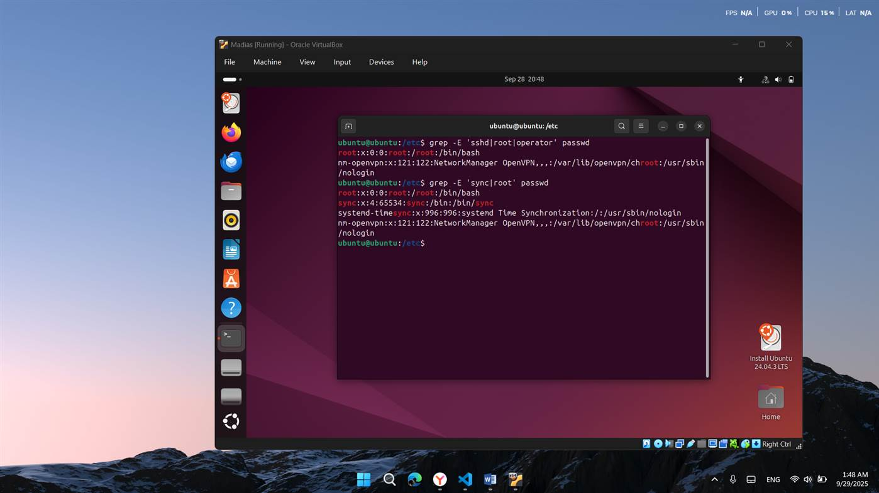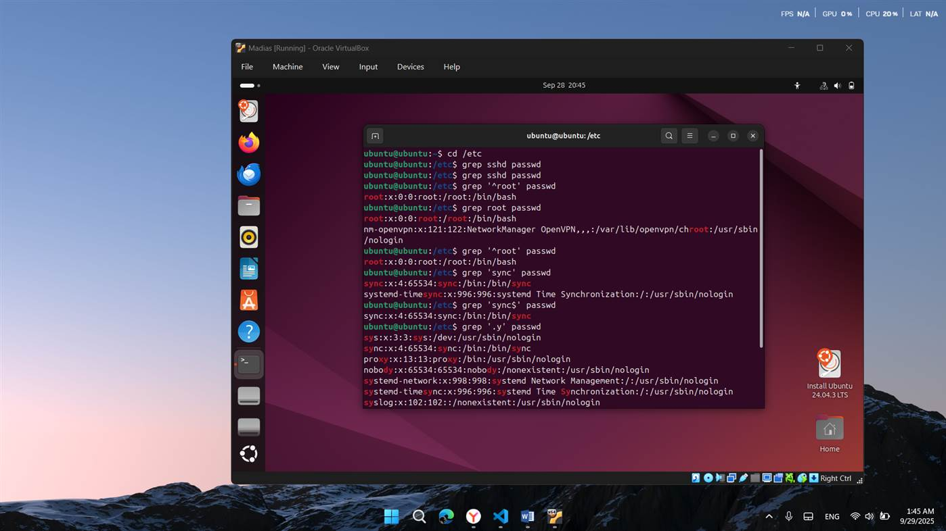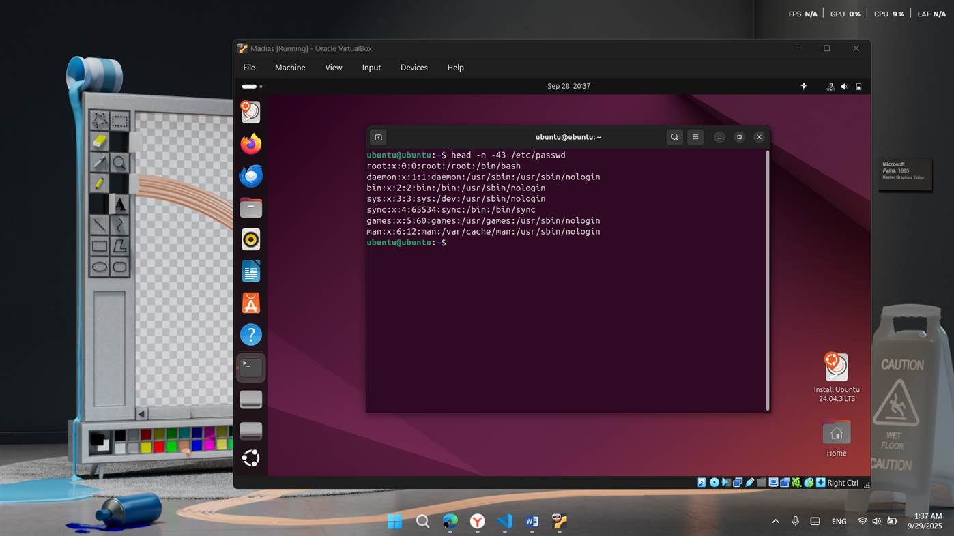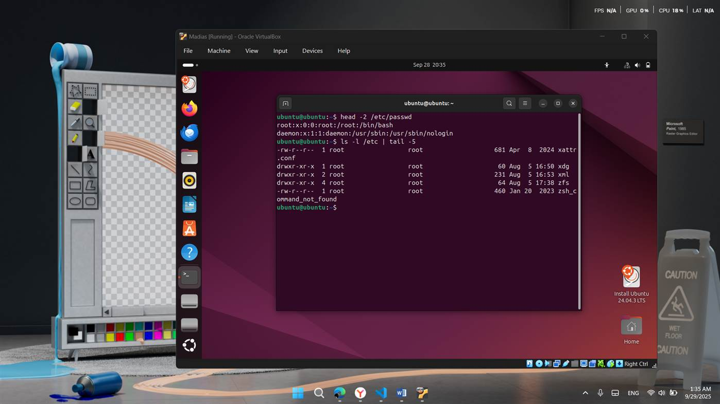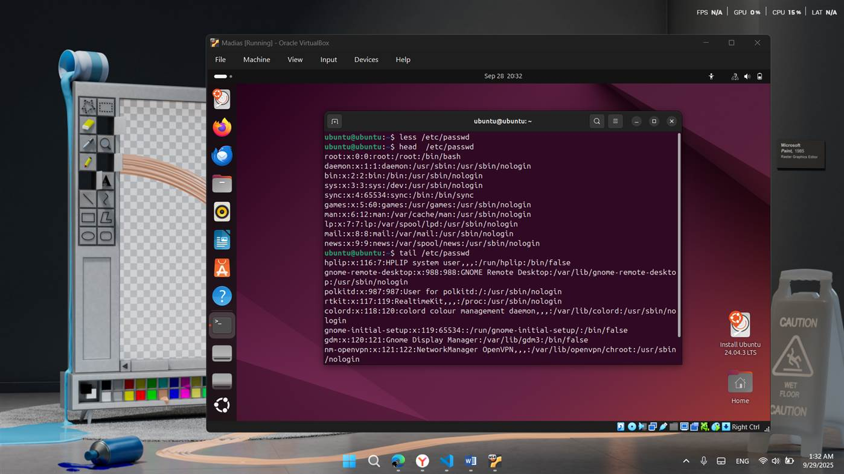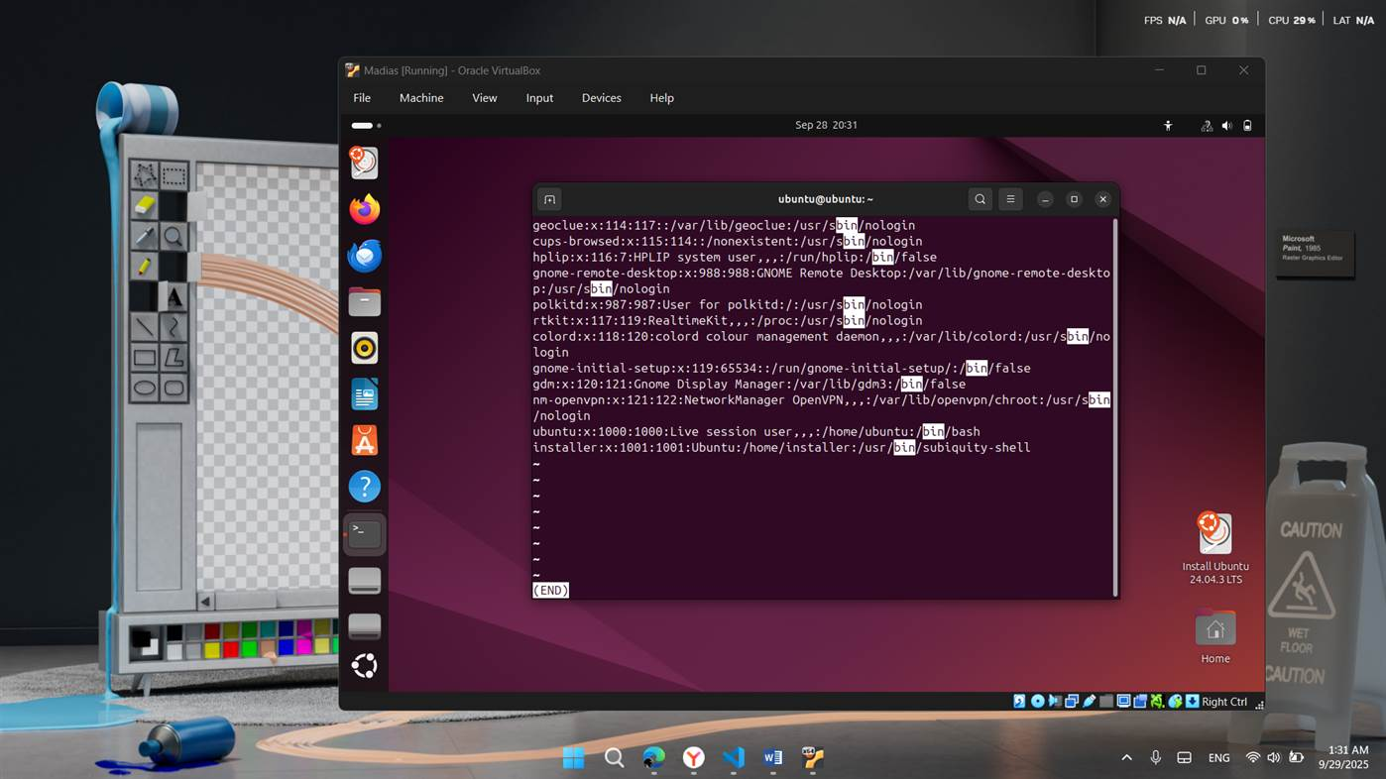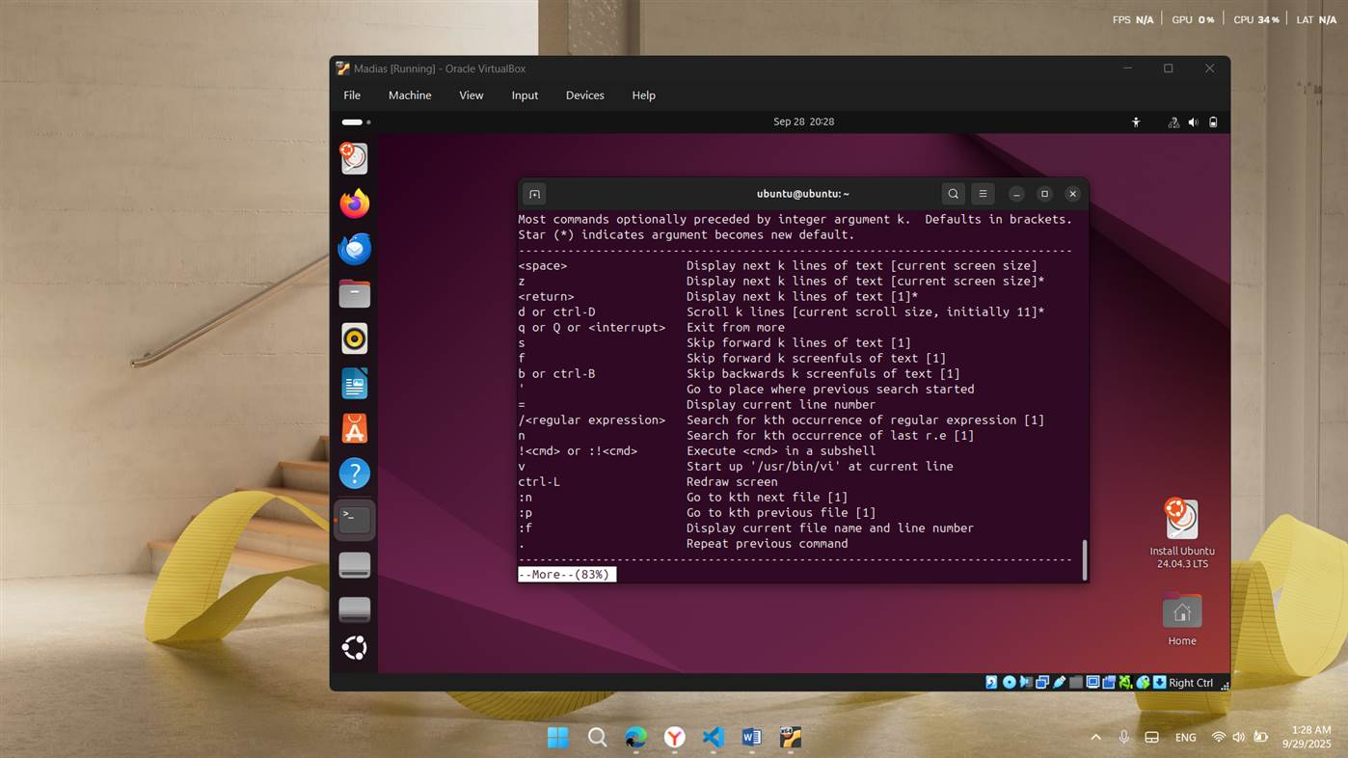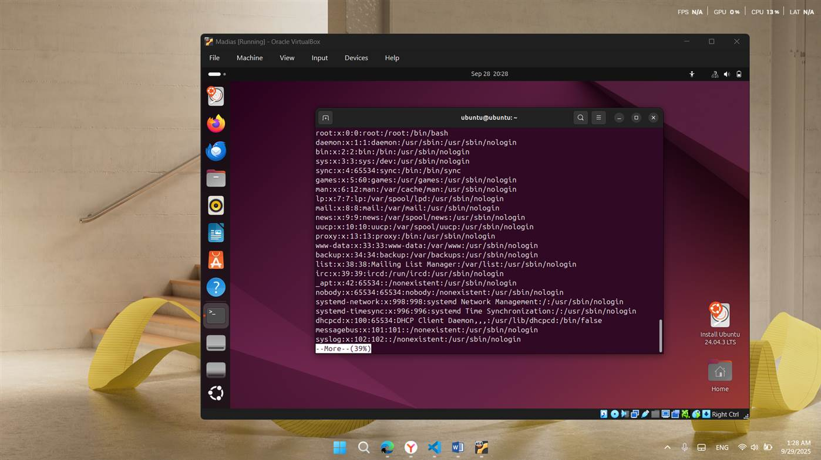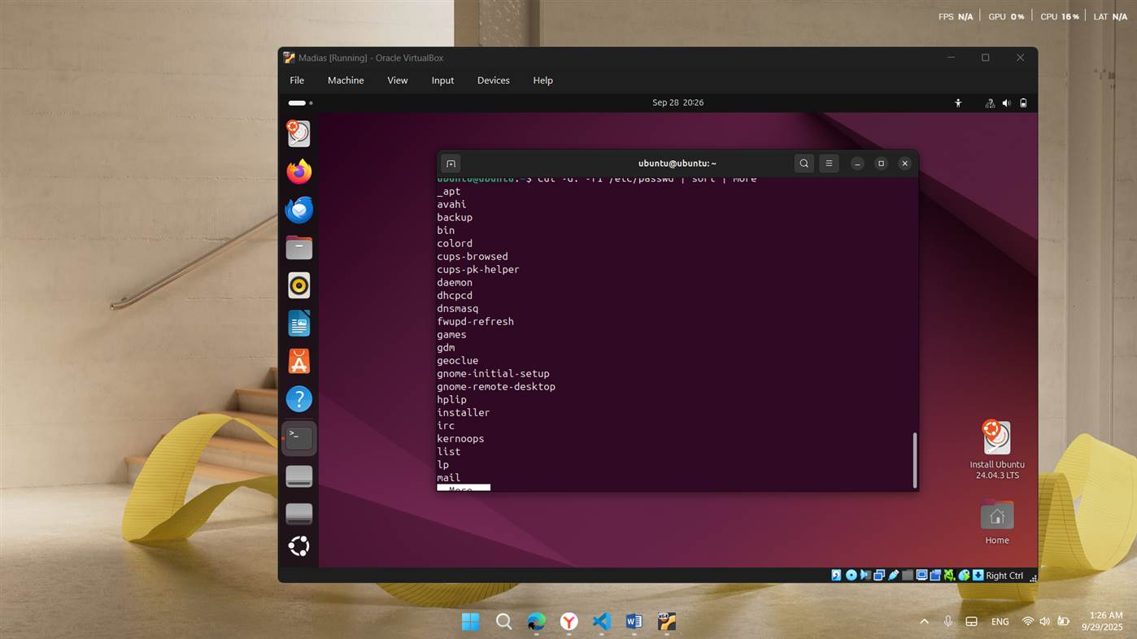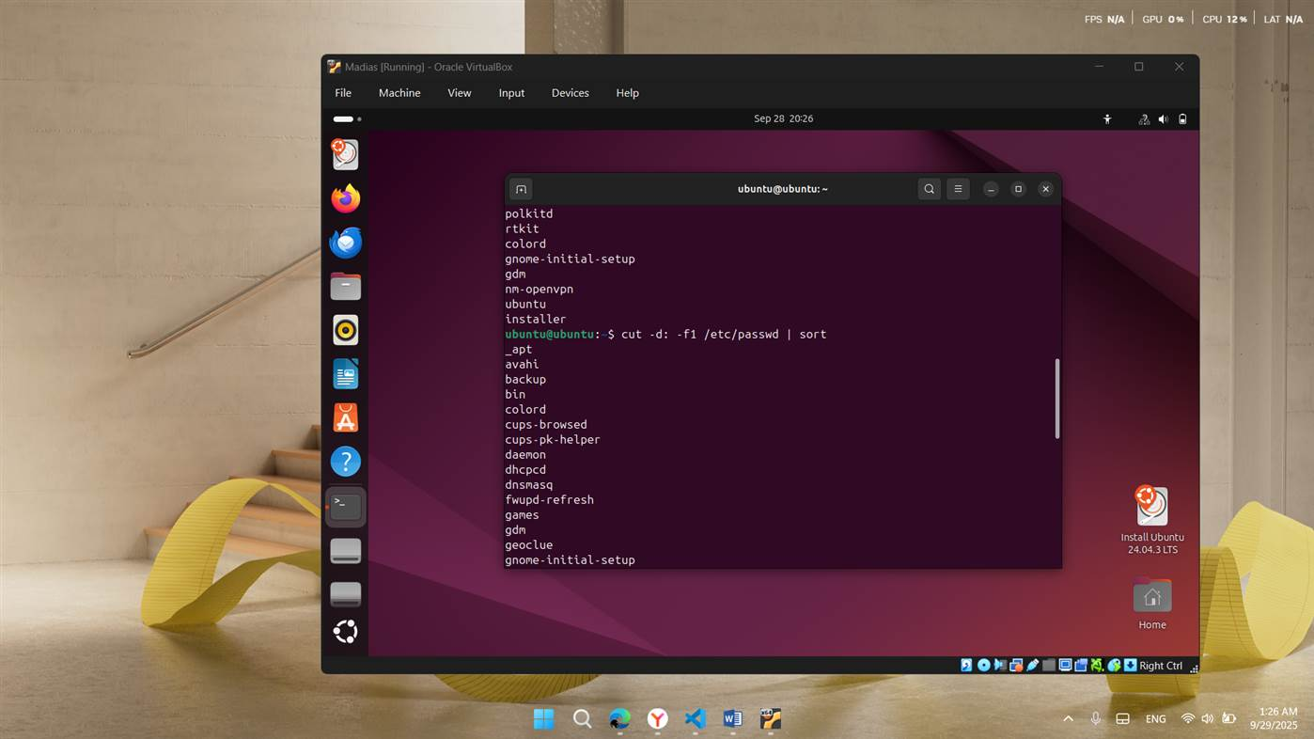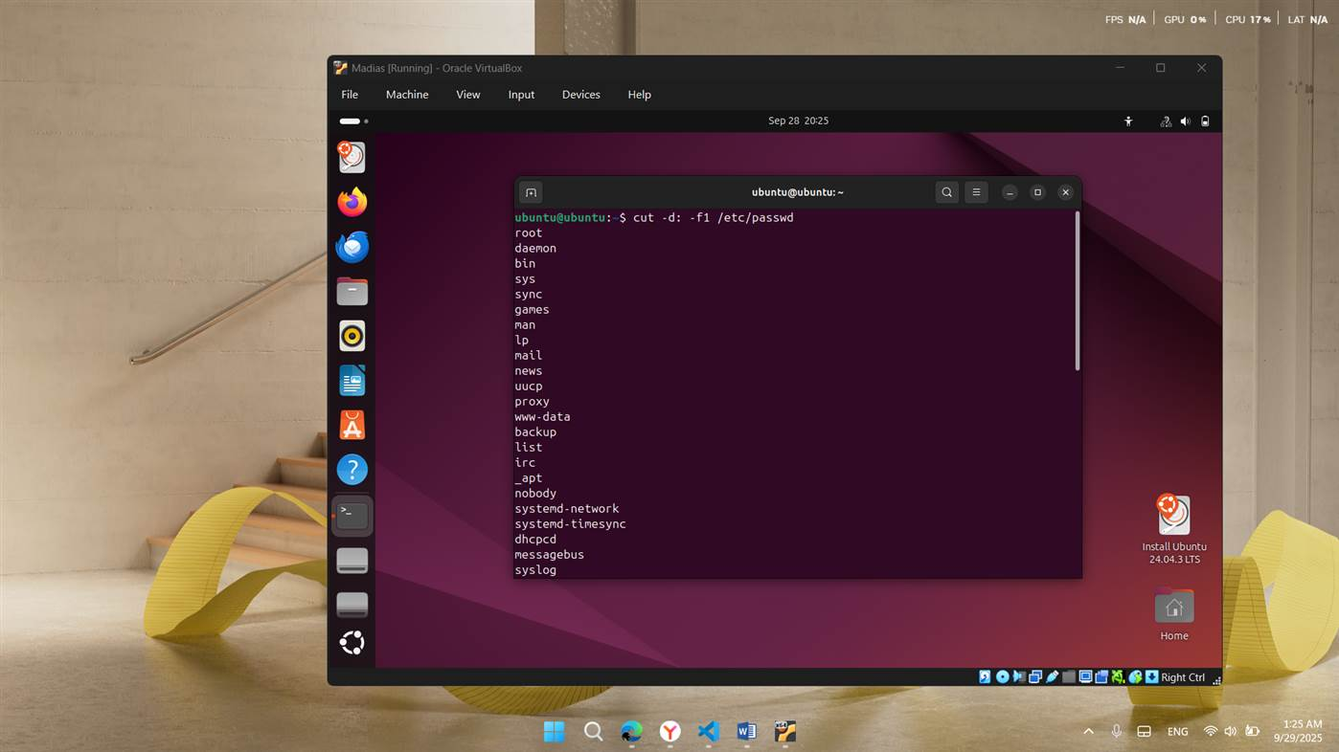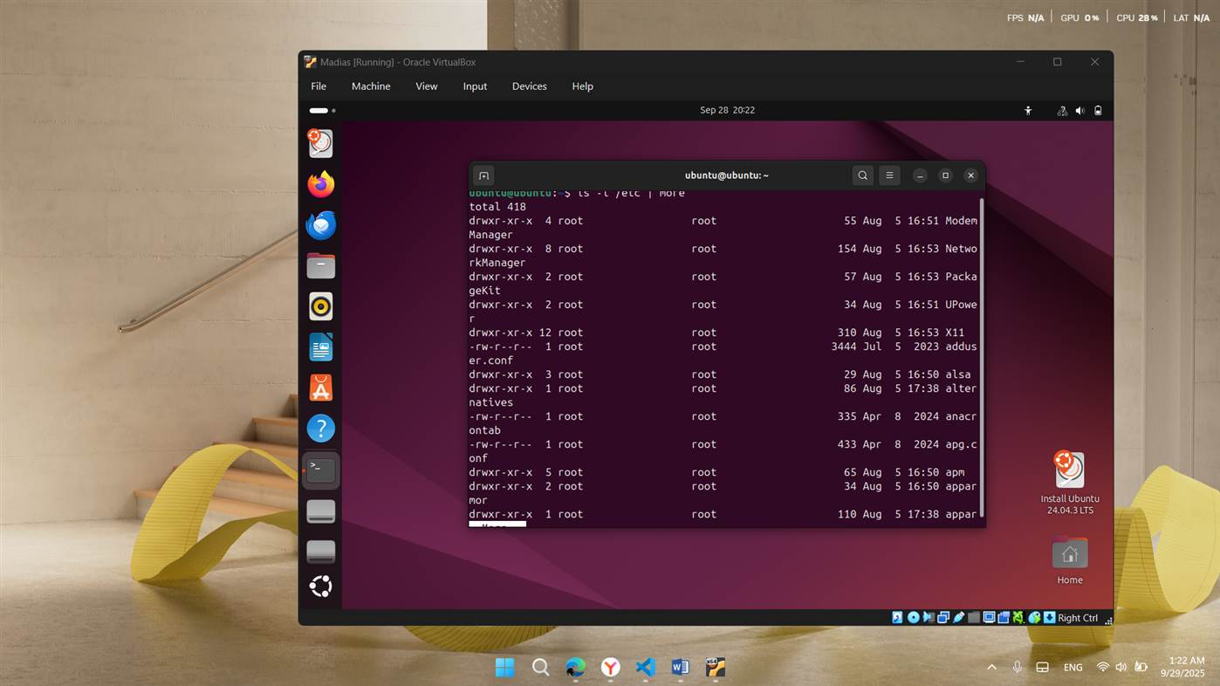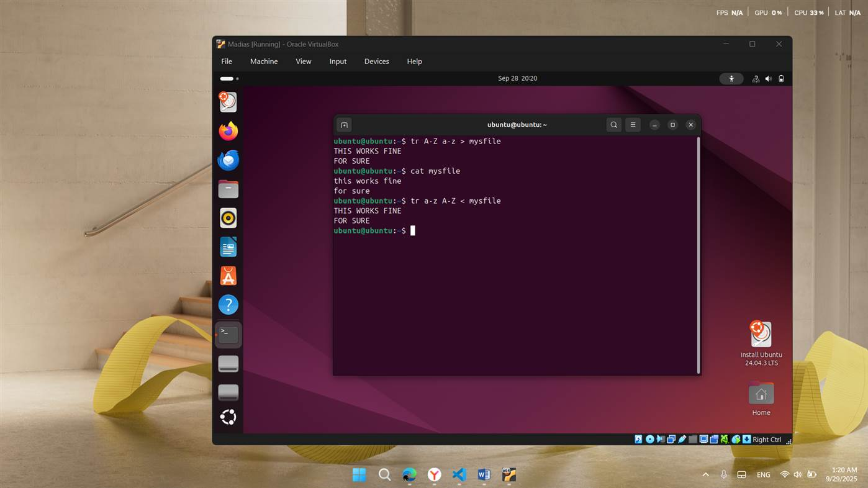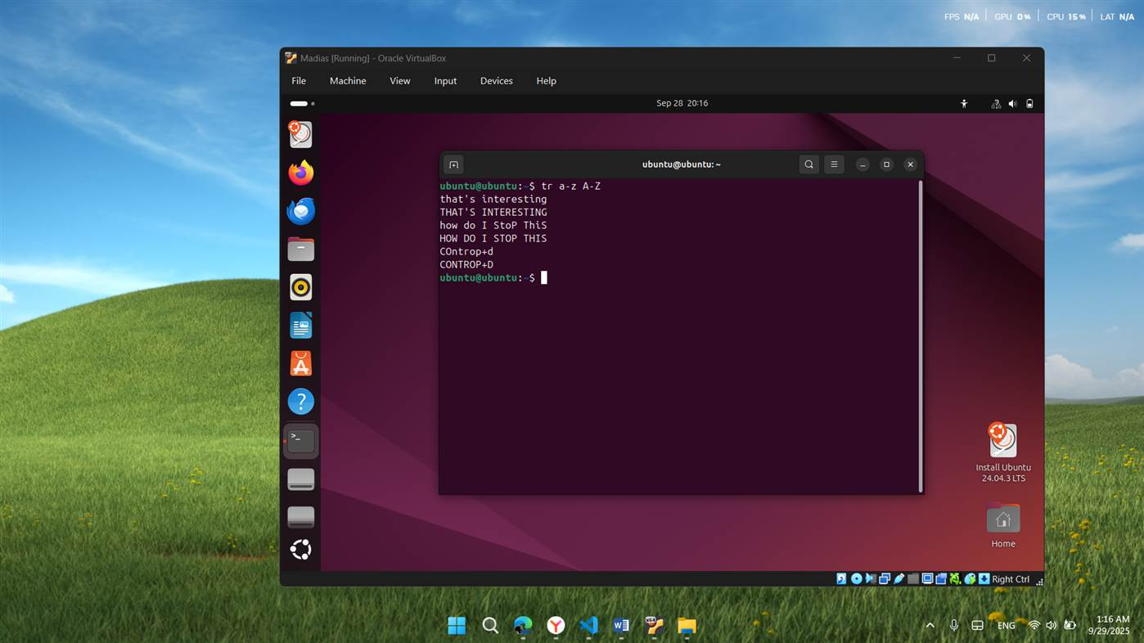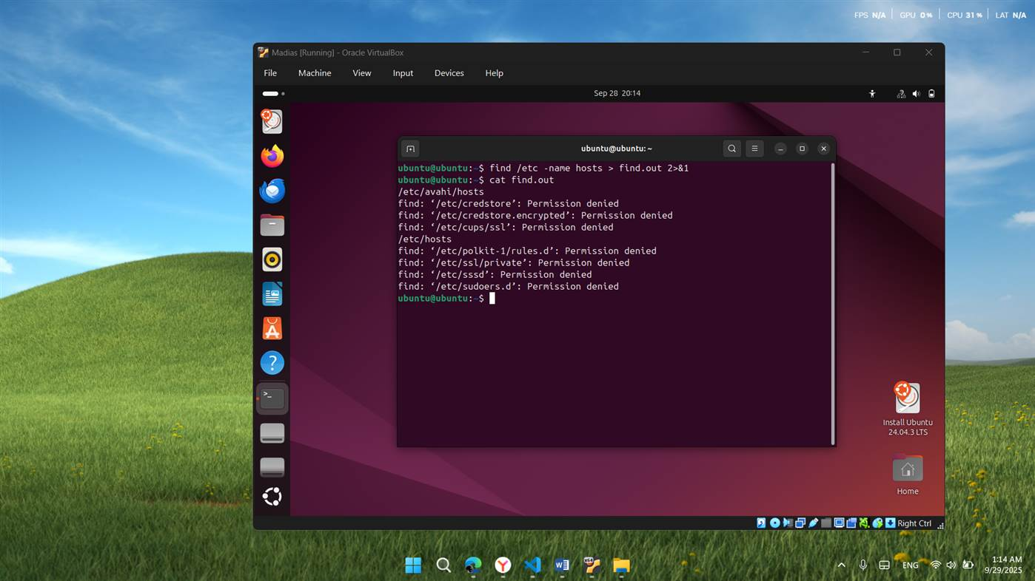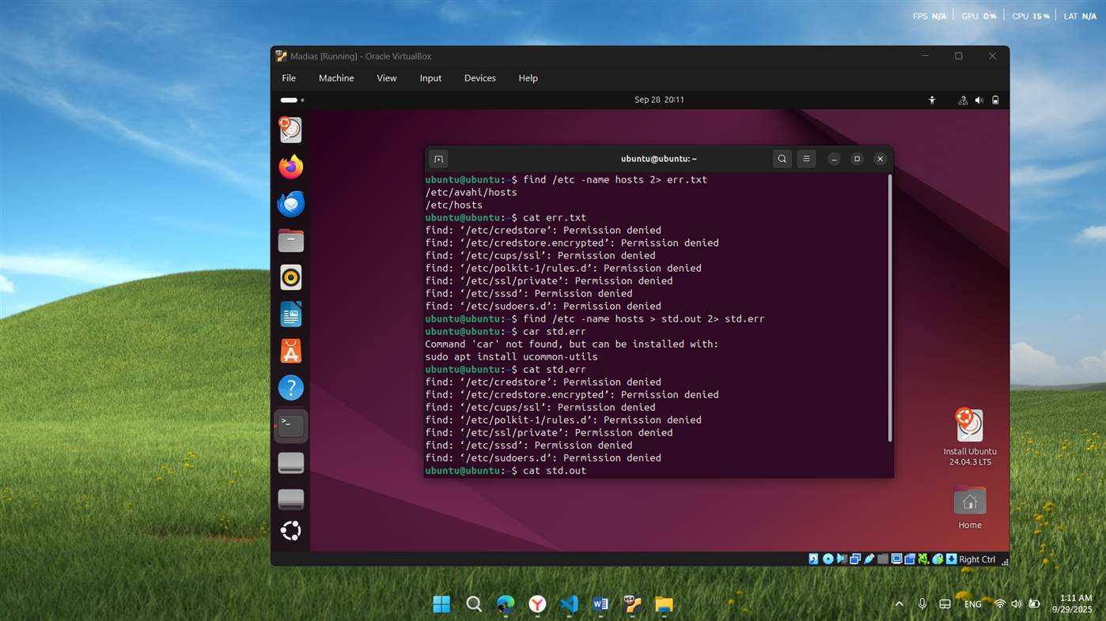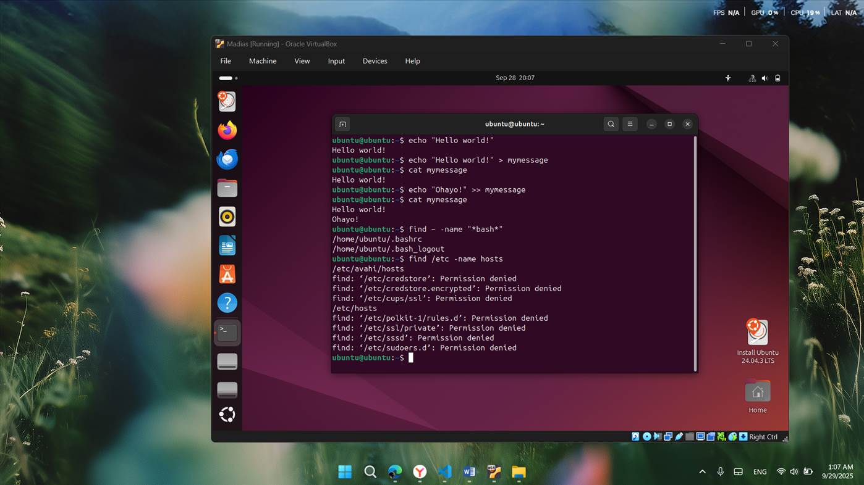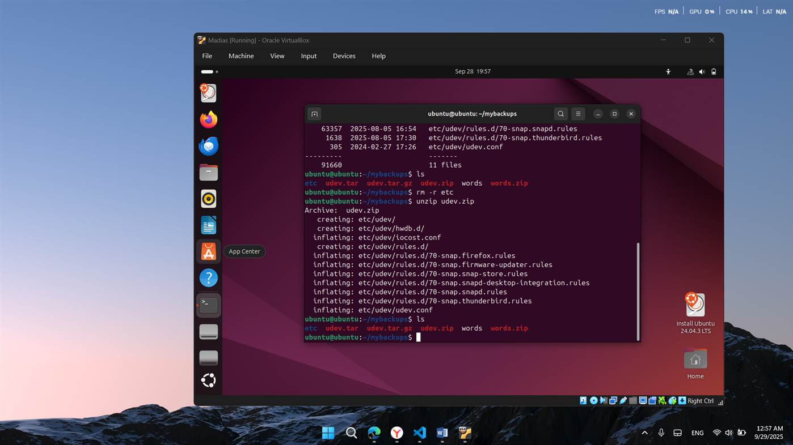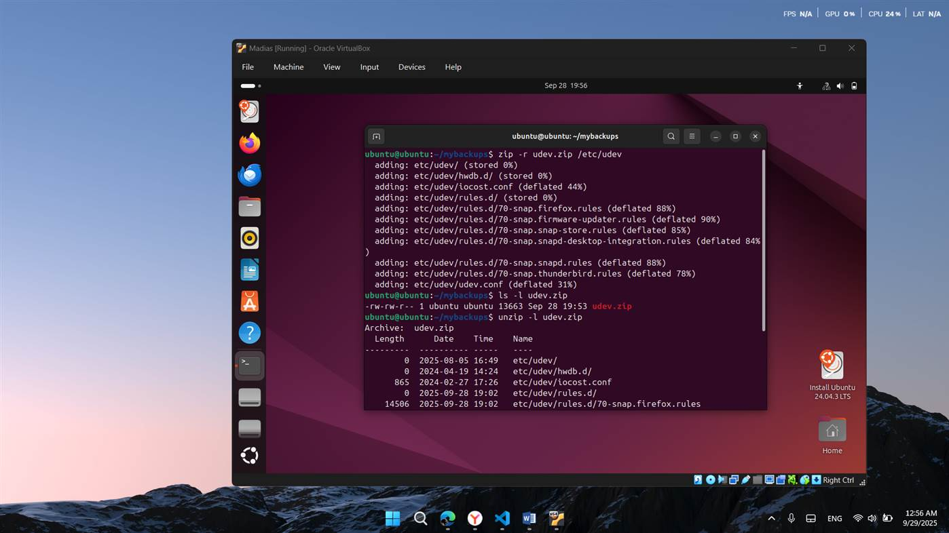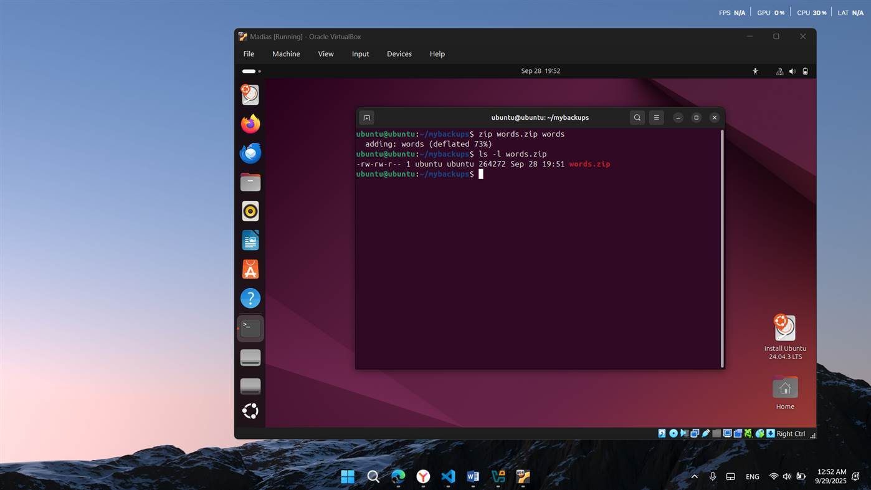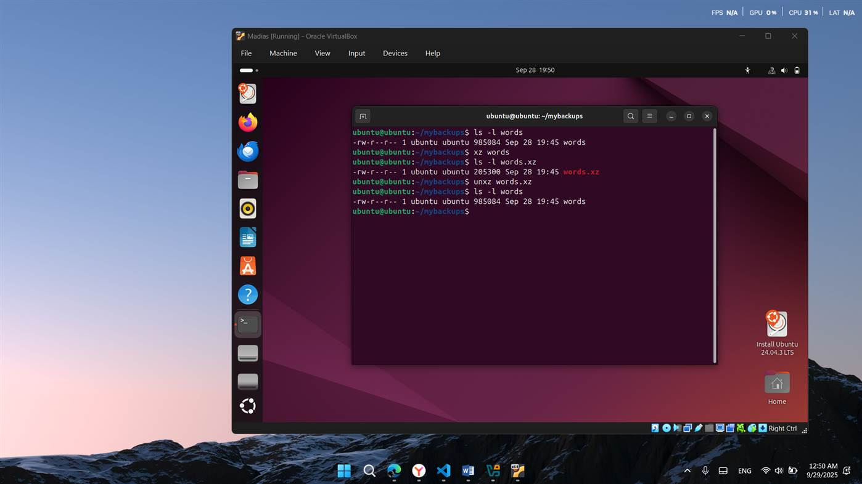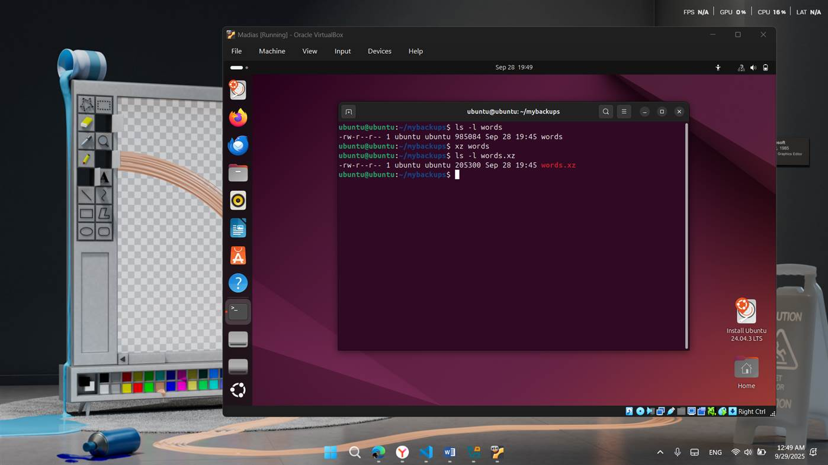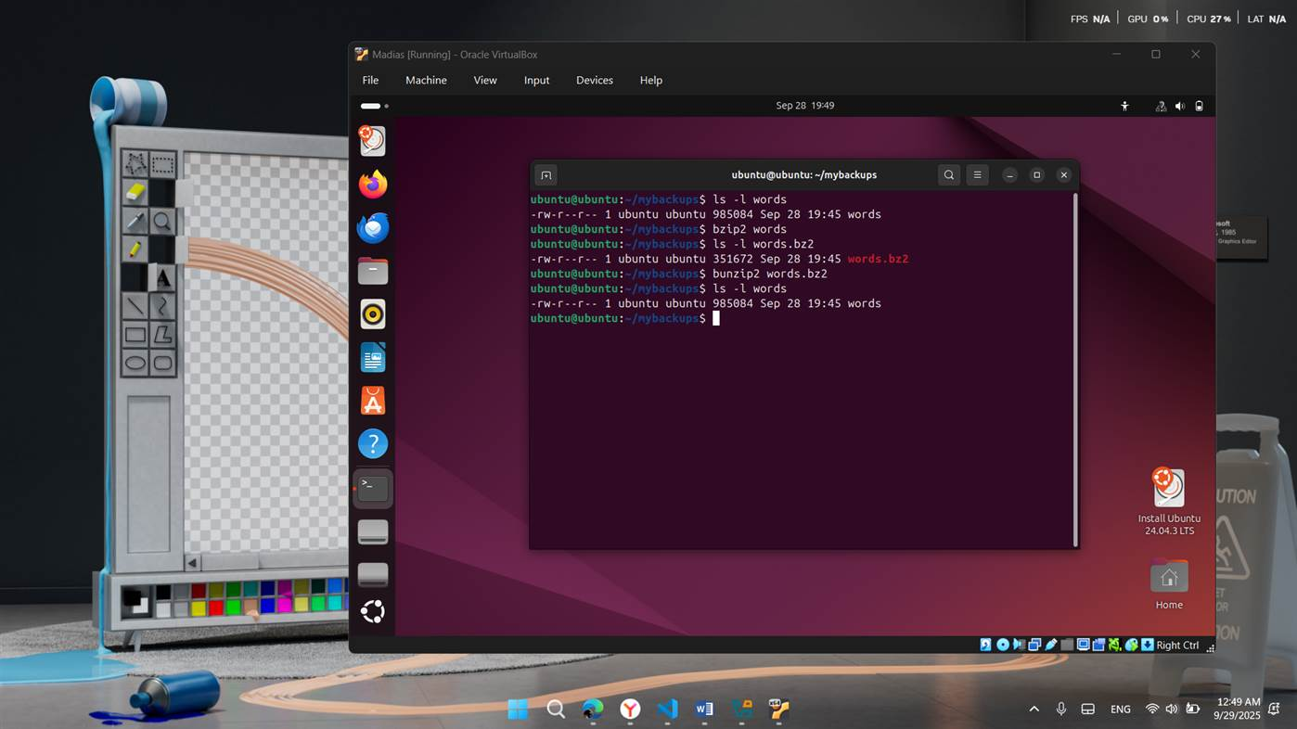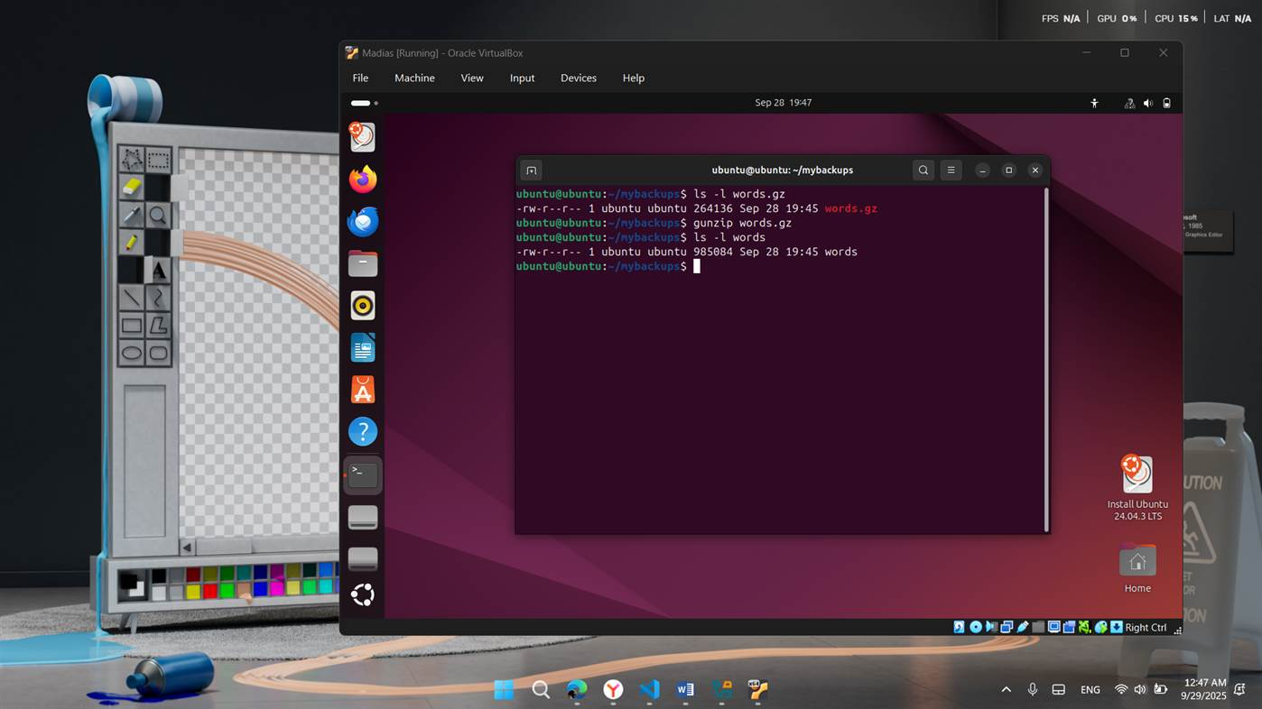

## ****3. Practical Linux Tasks****

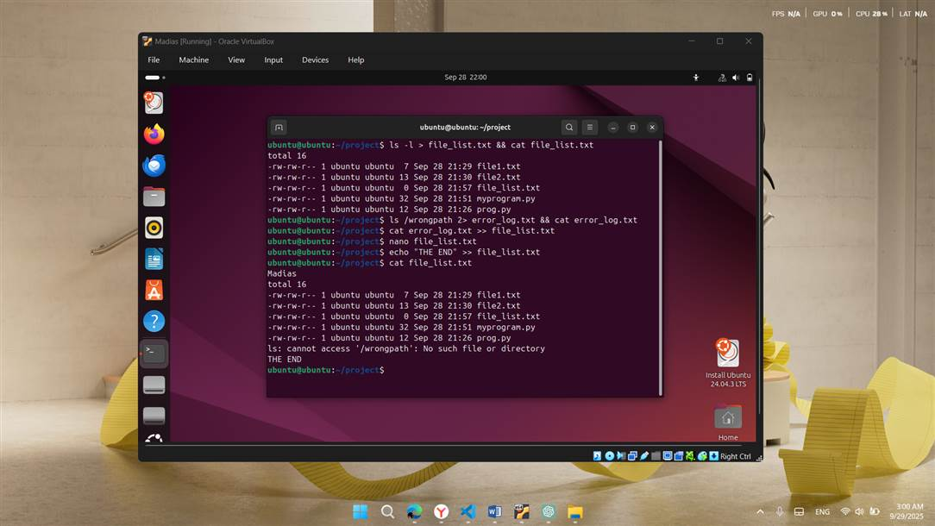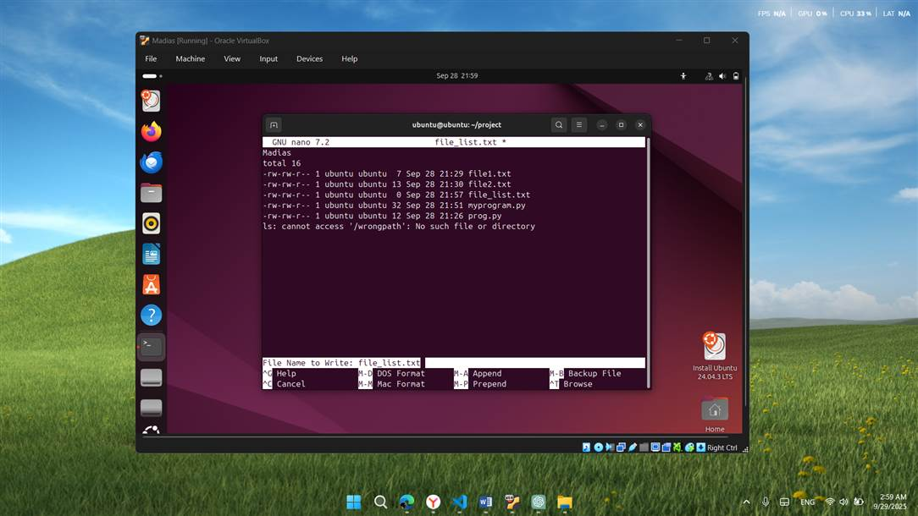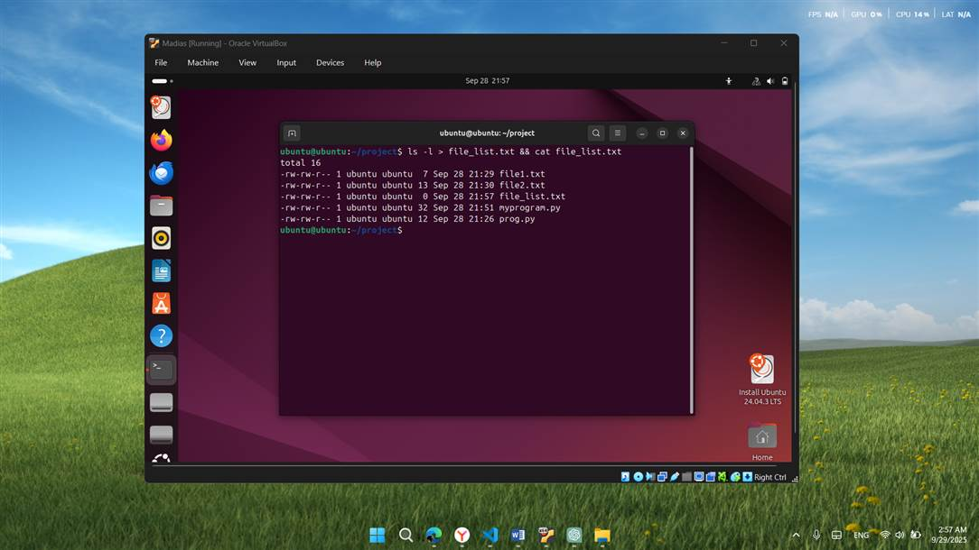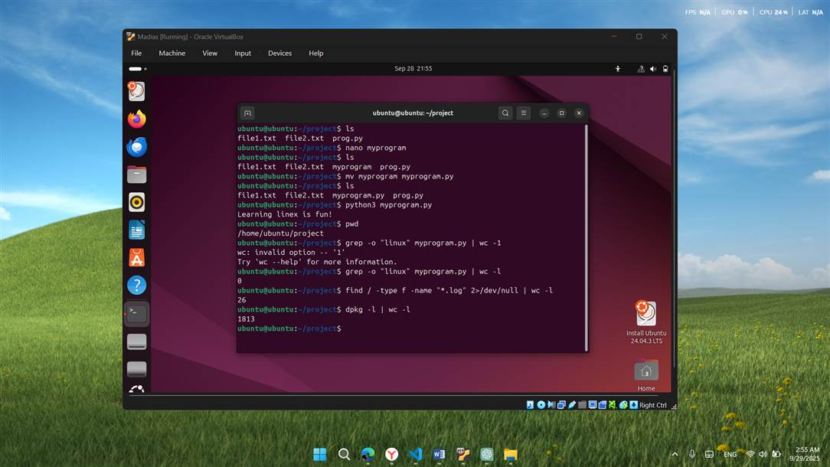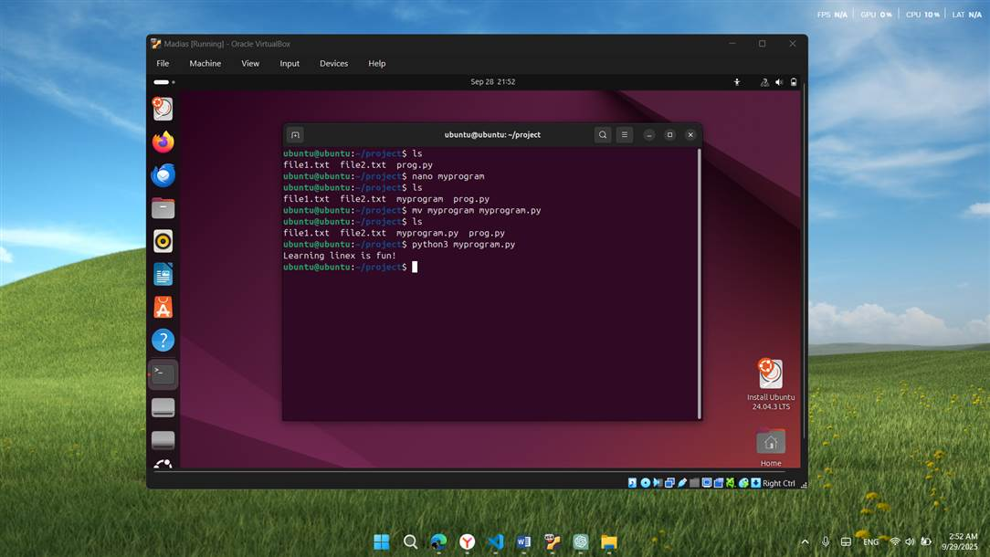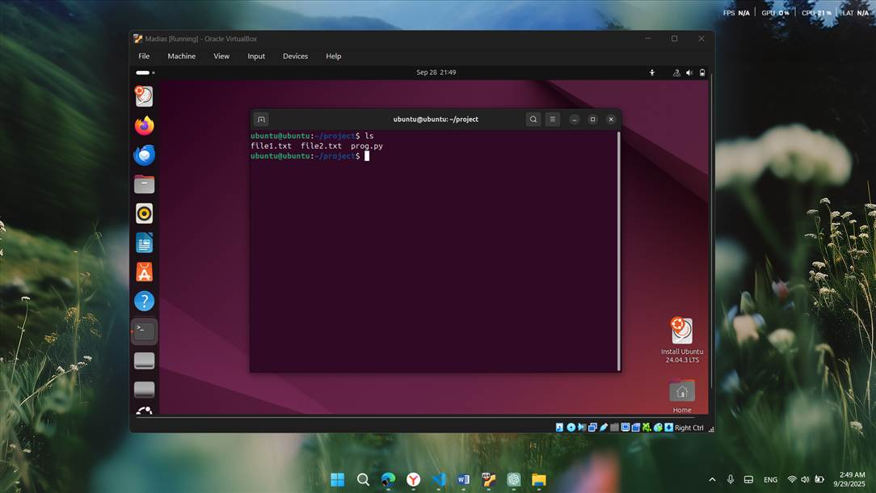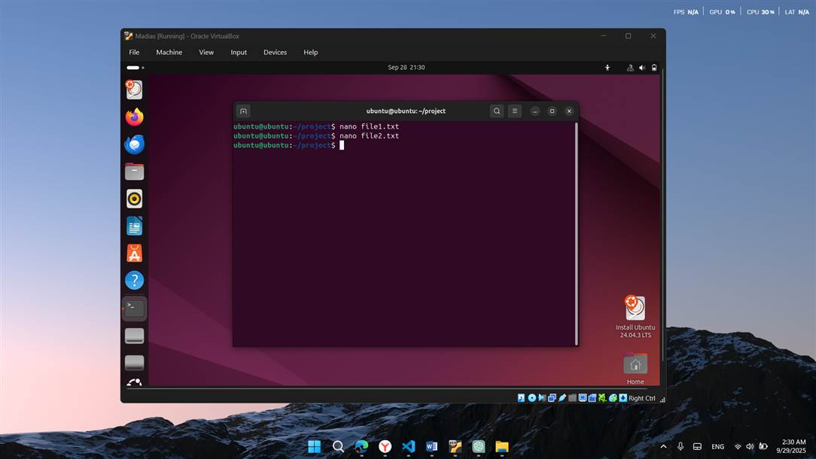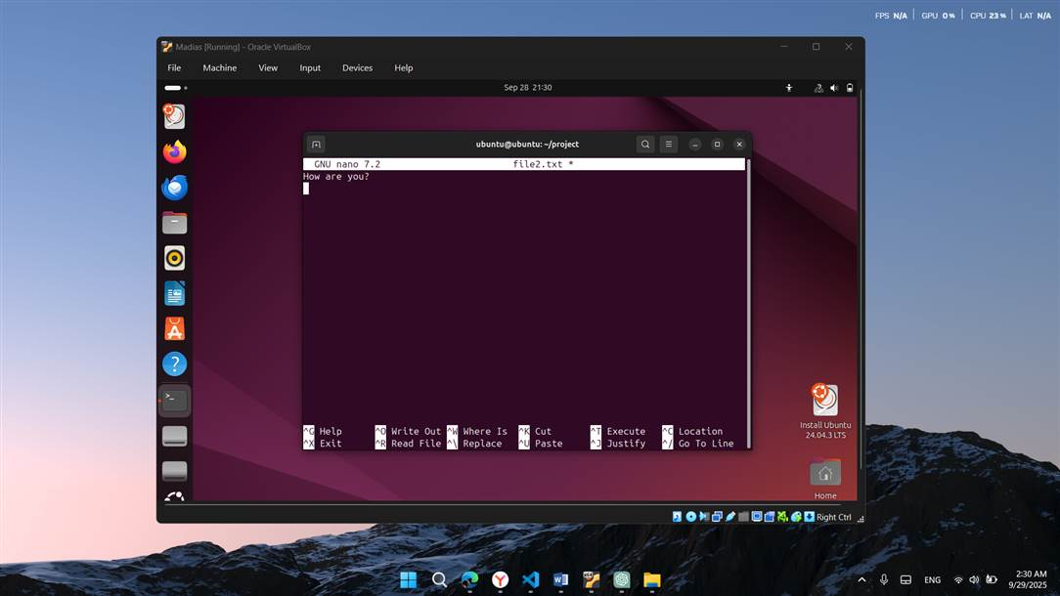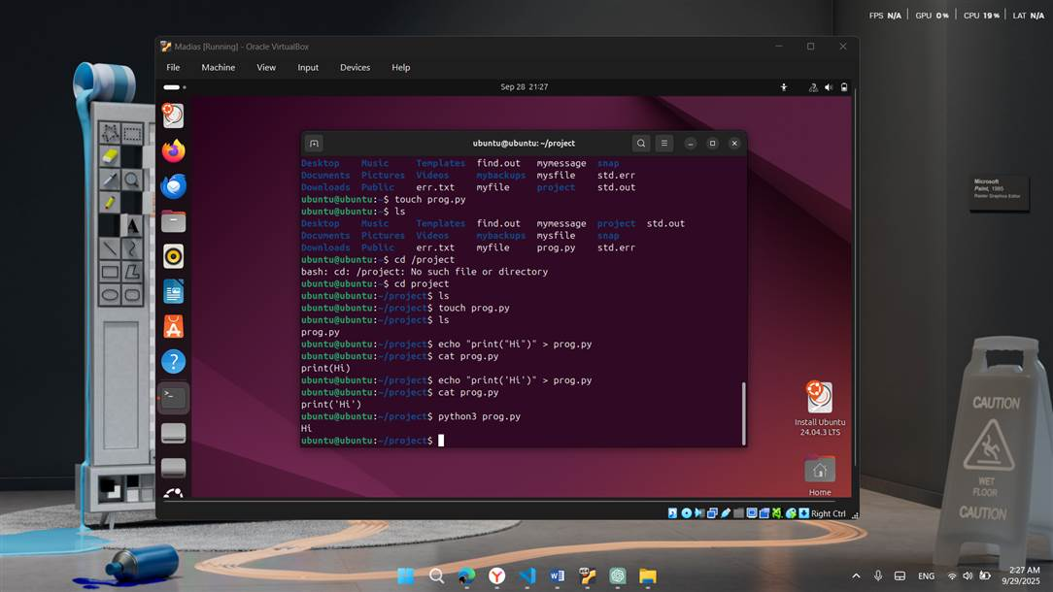

## ****5. Conclusion****

In this practical work, I successfully:

* Navigated the Linux file system and viewed directories
* Installed and updated packages with apt
* Used **nano** and **vim** for file editing
* Created and executed a Python program
* Practiced searching, counting, and checking logs/packages
* Learned redirection of outputs and error handling
* Combined all tasks into a structured workflow

This assignment helped me become more confident in using the Linux terminal and understanding how different commands connect together.